**Freshworks – Engineering – Assignment**

**Documentation**

Version 1.0

30/12/2020

**VERSION CONTROL**

|  |  |  |  |
| --- | --- | --- | --- |
| Version | Date | Created by | Details of Change |
| 1.0 | 30/12/2020 | Charles Samuel R  ([rcharles.samuel99@gmail.com](mailto:rcharles.samuel99@gmail.com)) | Initial version |

Contents

**1.** **Objective** 3

**2.** **Overview** 3

**3.** **Screenshots** 3

3.1 LOGIN 3

3.2 CREATE 3

3.3 READ 4

3.4 DELETE 4

**4.** **Code** 4

**5.** **Unit Testing** 4

**6.** **Code Quality** 5

**7.** **Conclusion** 5

# **Objective**

Build a file based key value data store that supports basic CRD (create, read and delete) operations.

# **Overview**

This is a simple Key-Value Data Store using Python and Mongo DB.

The program is set in the form of a web application using the Flask web framework in Python.

The main packages used in this application include:

* Flask - For web application
* PyMongo - To connect to Mongo DB

Full list can be found in requirements.txt (in Github - <https://github.com/charlescsr/crd_datastore/blob/master/requirements.txt>)

The app can be accessed at <http://127.0.0.1:5000/>

The operations involved in this data store include:

* Create - Creates a Key-Value pair with an optional TTL(Time-To-Live). Value is a JSON object
* Read - Read a Value that is created by the user
* Delete - Delete a Key-Value pair that the user created

** All artefacts available in Github - <https://github.com/charlescsr/crd_datastore>

# **Screenshots**

### 3.1 LOGIN

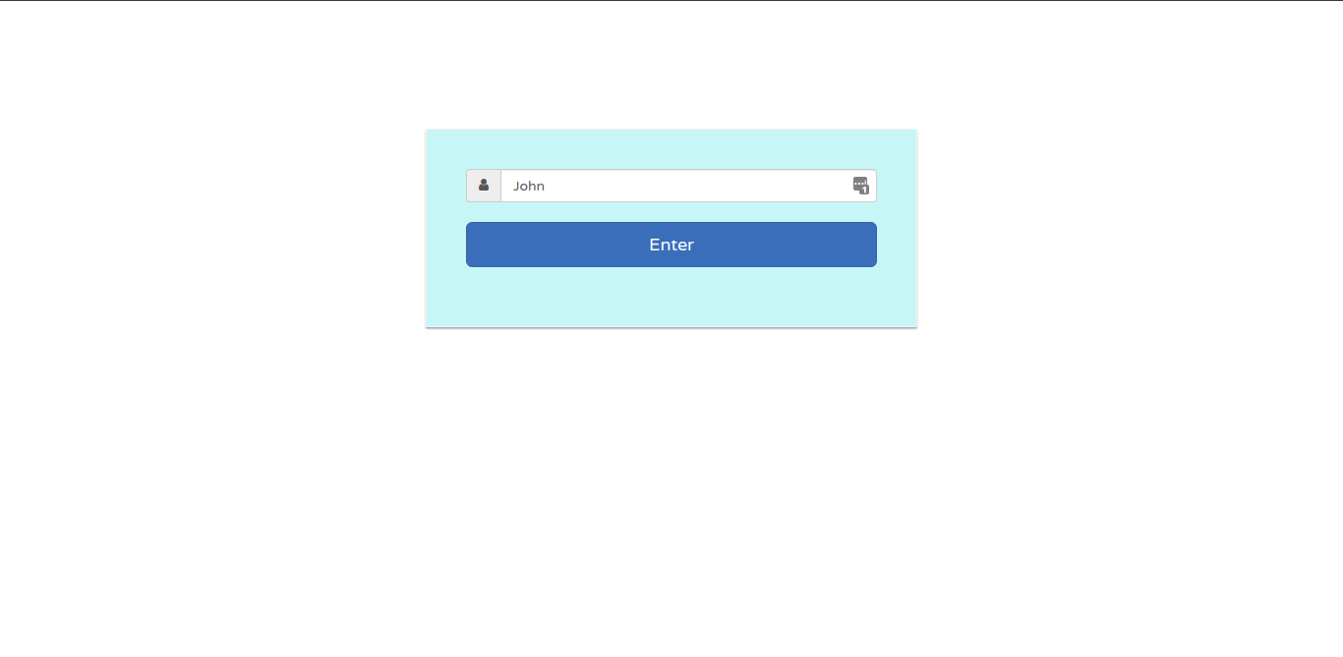

### 3.2 CREATE

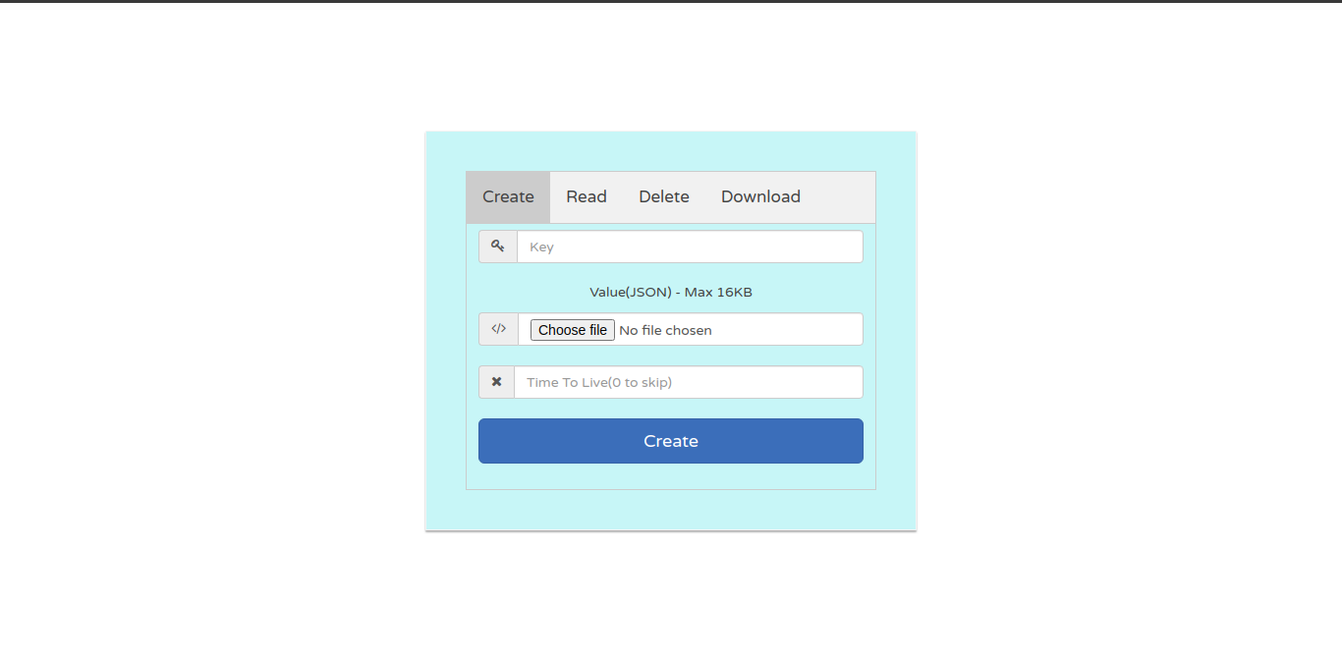

### 3.3 READ

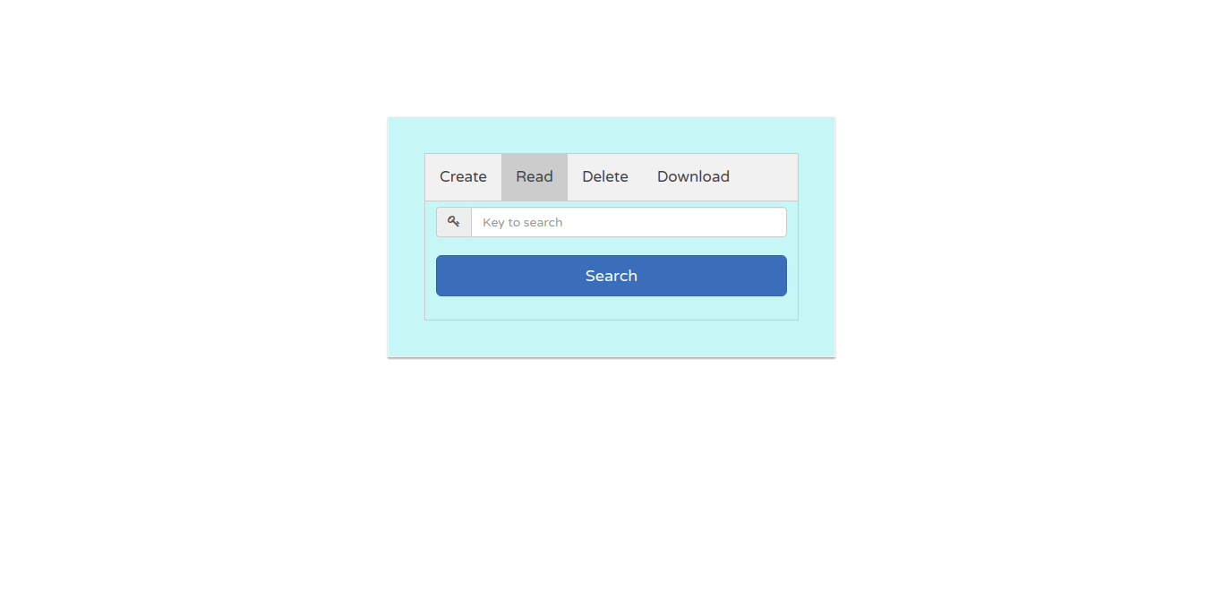

### 3.4 DELETE

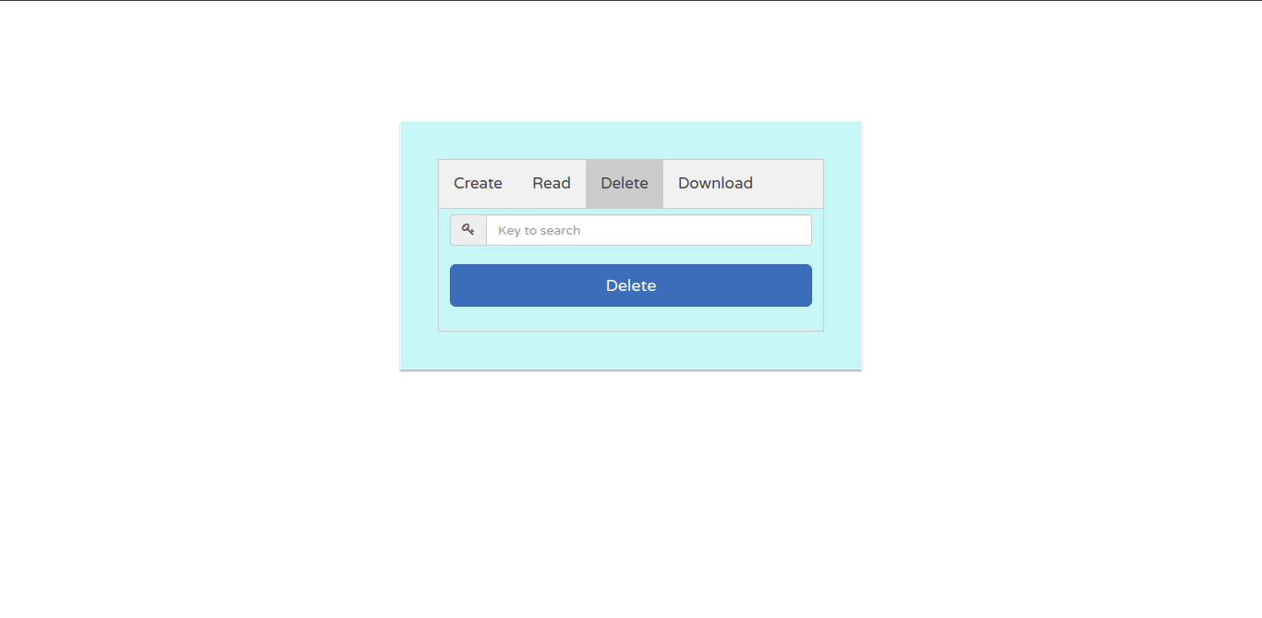

# **Code**

Developed code embedded below:



# **Unit Testing**

Unit testing was carried out as per the written down unit test cases and results recorded. Unit test cases, results:



# **Code Quality**

**9.92 / 10**

Validated through **Pylint**.

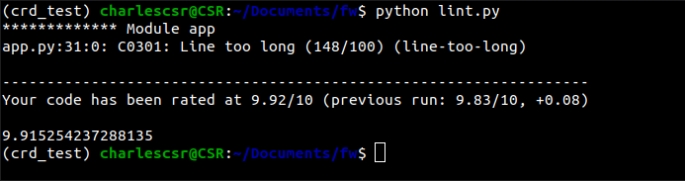

# **Conclusion**

The developed code can address the stated objective completely and with excellent code quality of 9.92 score. Many thanks to Freshworks for the opportunity provided to showcase the above and looking forward for a long and enriching career with Freshworks.